Assignment1:
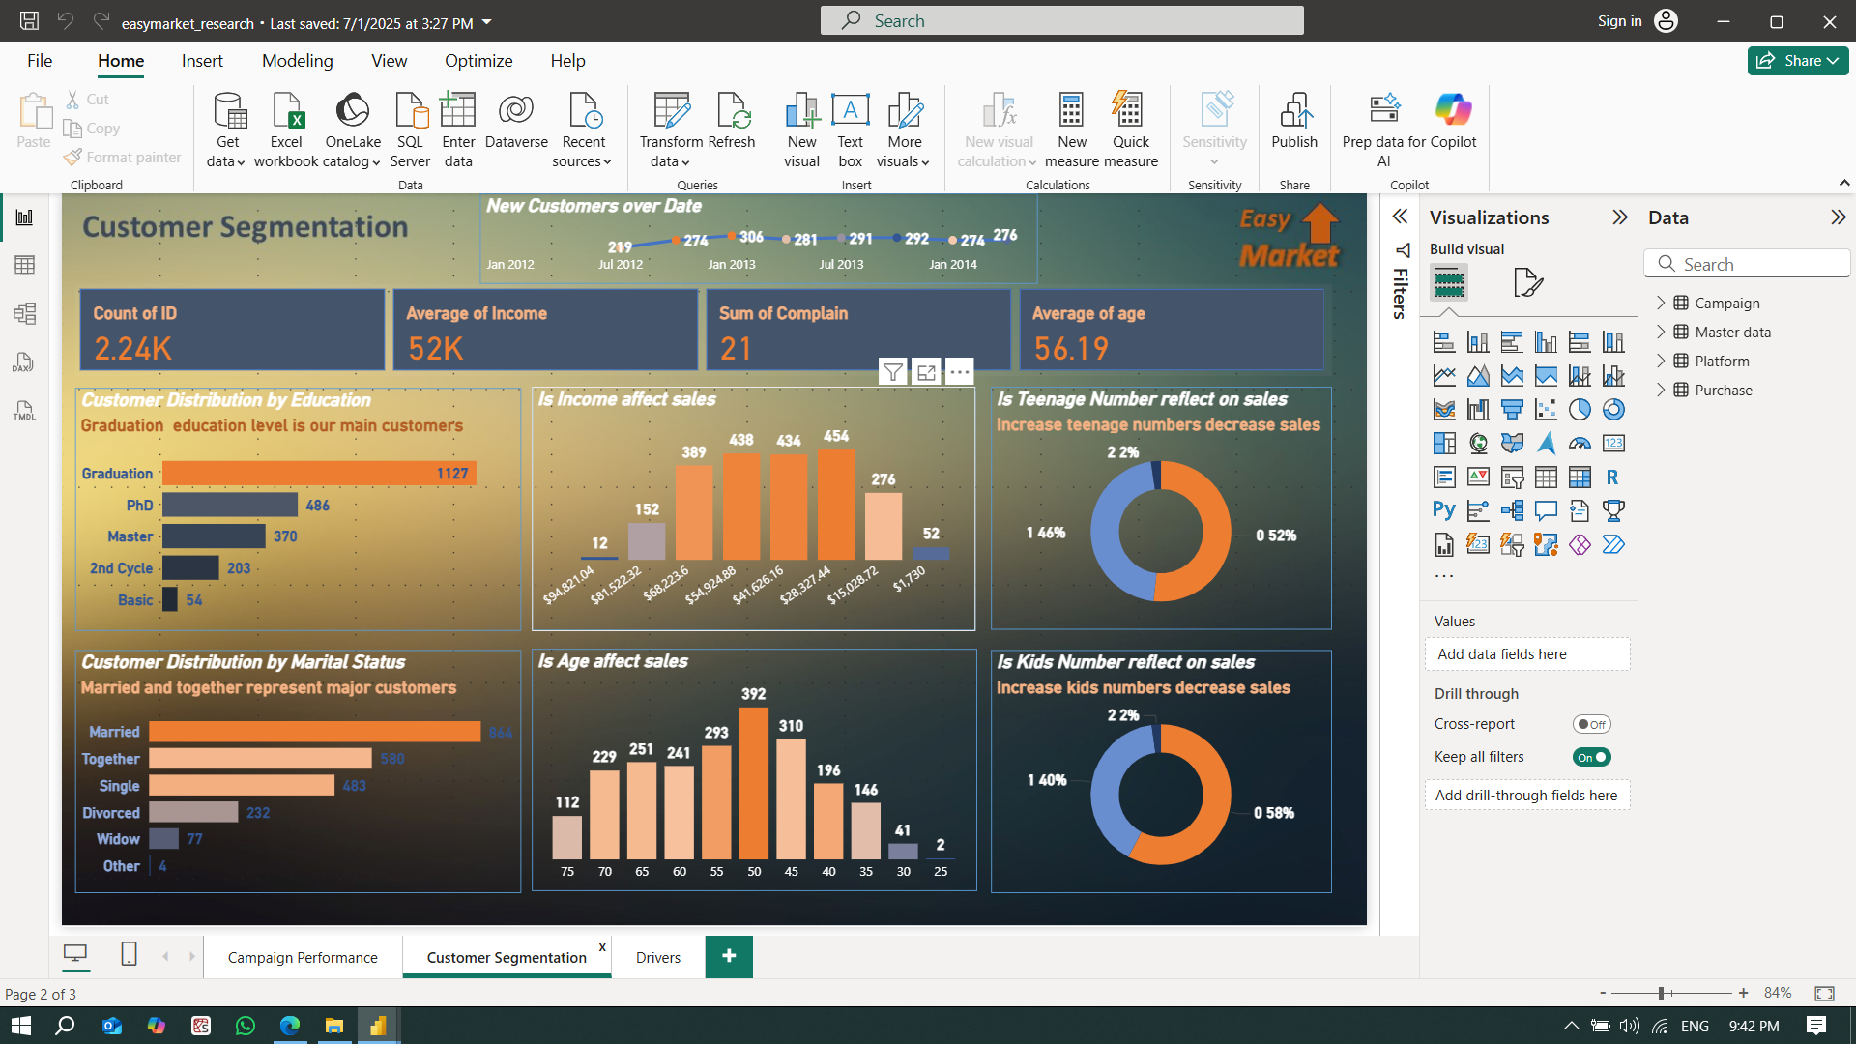

Please use file easymarket_schema.pbix to generate the above dashboard.
You must use background image that included in zip file and use power point to get related palate and make current themes in power bi use power point pallet.

Assignment2:
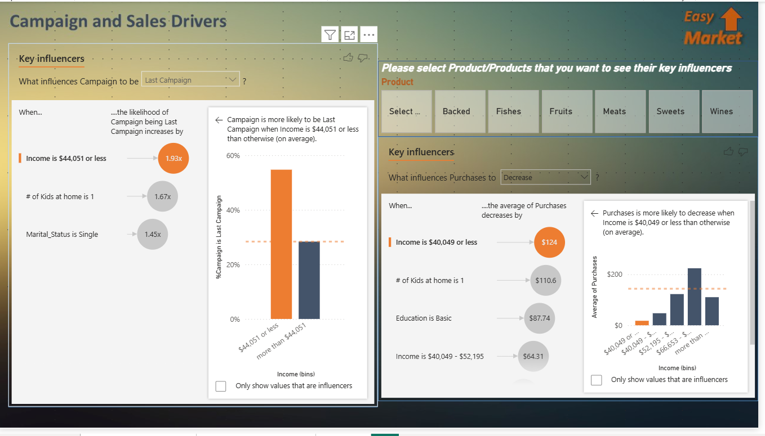
On Same Schema build displayed dashboard

